Assignment 3 Report
Rohan Javed
22L-6545

Supply Chain Management DApp (Polygon + Hardhat)

Objective
Build and deploy a blockchain-based supply chain decentralized application (DApp) where products move through the lifecycle:
Manufacturer → Distributor → Retailer → Customer
The system ensures full transparency, traceability, and tamper-proof audit history using blockchain technology.

1. Smart Contract Design
Contract File:
contracts/rohan_supplychain.sol

Key Features Implemented
- Role Management
  - Manufacturer
  - Distributor
  - Retailer
  - Customer
- Product Structure
  - Product ID
  - Name
  - Description
  - Current Owner
  - Status
- Core Functionalities
  - Only Manufacturer can register products
  - Ownership transfer follows sequence:
Manufacturer → Distributor → Retailer → Customer
  - Full on-chain audit trail with history tracking

2. Compilation and Testing Steps

Step 1: Install Dependencies
npm install

Step 2: Compile Smart Contract
npx hardhat compile

Step 3: Run Tests
npx hardhat test

3. Deployment Steps (Sepolia Testnet)

Step 1: Setup Environment Variables
copy .env.example .env

Step 2: Configure .env
Add the following values:
- SEPOLIA_RPC_URL
- PRIVATE_KEY
- ETHERSCAN_API_KEY

Step 3: Deploy Contract
npx hardhat run scripts/deploy.js --network sepolia

Step 4: Verify Contract (Optional)
npx hardhat verify --network sepolia <DEPLOYED_CONTRACT_ADDRESS>

4. Deployment Evidence
Contract Address:
0x2D0AEc67459c79744A886fAd121b63aDa07E0bfd
Transaction Hash:
0x29c5fd2713fdf85cce662dfa2b0fcf8351ef17a8d0922a0b61f621f1e4c5cc22
Etherscan Links:
https://sepolia.etherscan.io/address/0x2D0AEc67459c79744A886fAd121b63aDa07E0bfd
https://sepolia.etherscan.io/tx/0x29c5fd2713fdf85cce662dfa2b0fcf8351ef17a8d0922a0b61f621f1e4c5cc22

5. Frontend Implementation
Frontend Files:
- frontend/index.html
- frontend/styles.css
- frontend/app.js

Usage Instructions
- Open index.html in a browser (or use a local server)
- Connect MetaMask wallet
- Enter deployed contract address
- Perform actions:
  - Register products
  - Transfer ownership
  - View product history

6. Snapshots
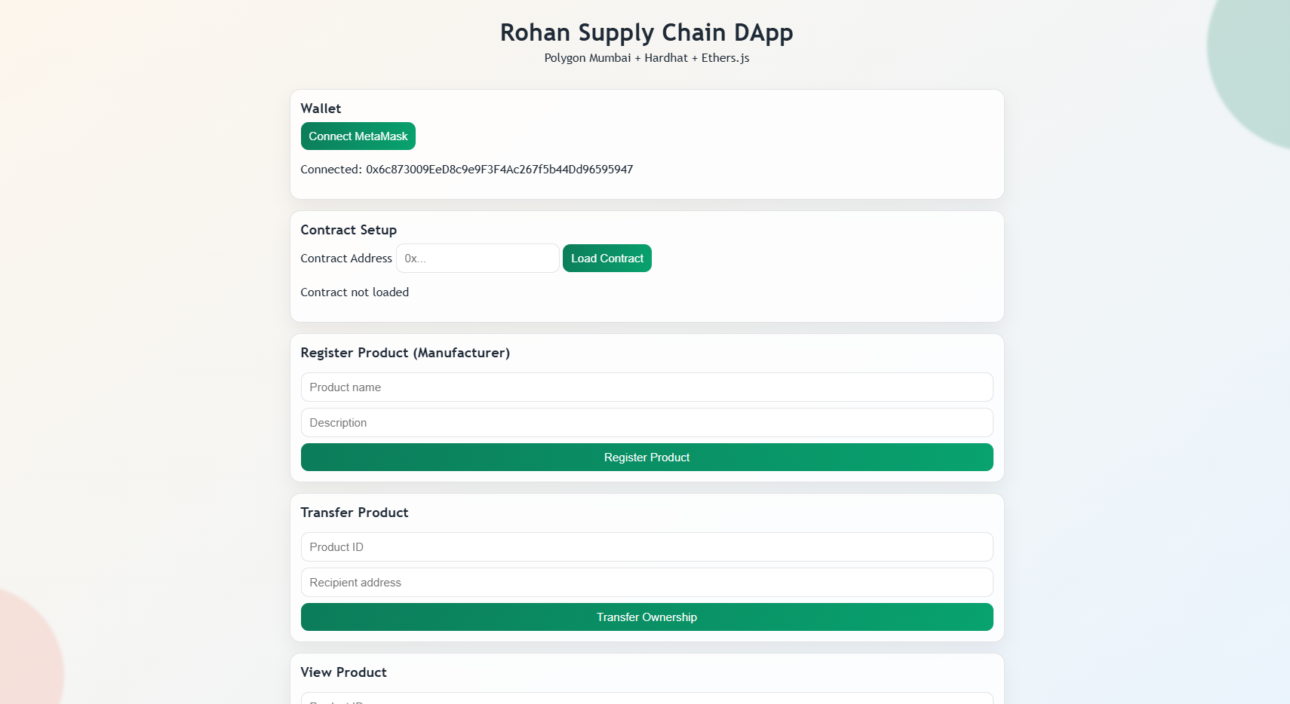
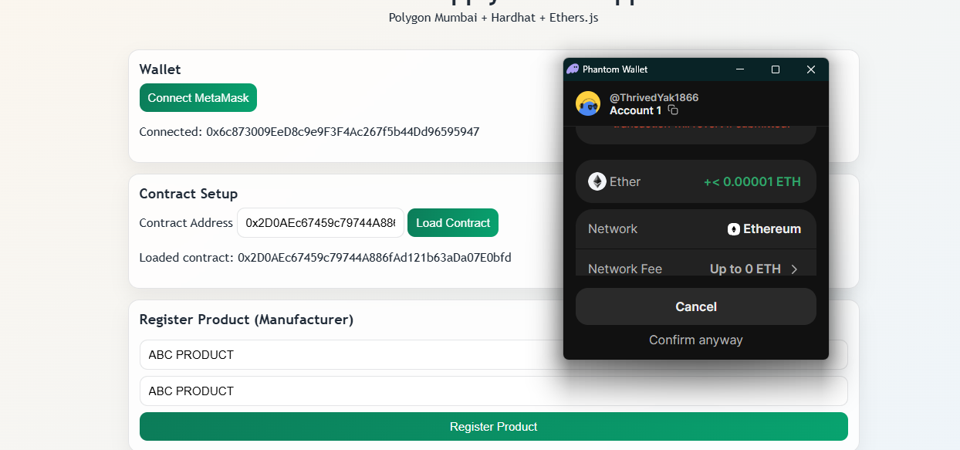
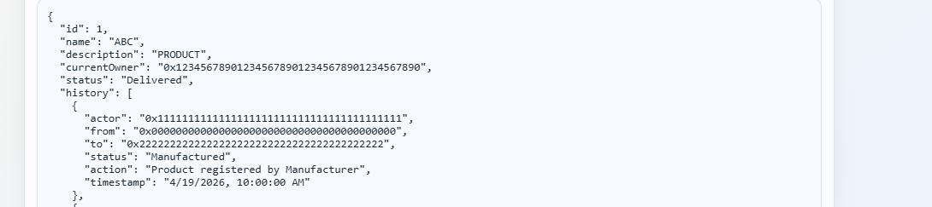

Conclusion
This project demonstrates the use of blockchain in supply chain management to ensure transparency, security, and traceability. The system enforces role-based control and maintains a verifiable product journey across all stages.

